|  |  |
| --- | --- |
|  | Operational Strategy Analysis of ERP Muesli Inc. |
|  | Brian Pan |
| 4/8/2024 | Executive Summary |
|  | This analysis is conducted during the 2024 fiscal year to share Enterprise Operations analytics with the CEO of ERP Muesli Incorporated. The data for this analysis is retrieved from an SAP S4 HANA server at the California State University, Sacramento using an OData connection and the analysis is performed using Tableau Desktop 2022. Among the many operational database tables, only the relevant data for this analysis is used.  The findings of this analysis could be used as the foundation for the organization’s strategy execution for the 2024 fiscal year. Our analysis finds that:   1. Current Assets is a leading indicator of cash flow issues, suggesting the health of our sales may be a direct root of difficulties in meeting sales targets. 2. Geographic depictions of sales suggest a lack of reach with the potential customer base. 3. Supply-side performance metrics such as manufacturing efficiency and transfer efficiency point to no issues with production. |

Operational Strategy Analysis of ERP Muesli Inc.

Analysis of operational data

This analysis, conducted within the 2024 fiscal year, endeavors to unravel the reasons behind the underperformance of the breakfast cereal industry. Our focus lies in comparing two distinct companies within the industry to discern relevant insights. All interpretations are exclusively drawn from the data provided by our server; we have not referred to any external databases. While considering external market factors such as the GDP, unemployment rate, government policies, and global events, we assume their impact to be consistent and of minimal significance throughout our analysis.

To enhance our comprehension, we will initially examine our dataset to identify the company demonstrating the least favorable performance and the one exhibiting the most promising outcomes. This process will entail a thorough comparison of the income statements of Companies A through H.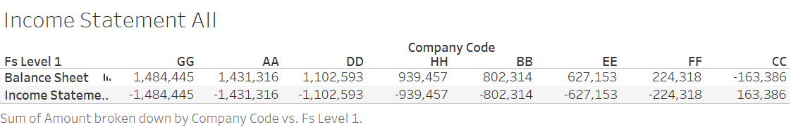

Here, we present the companies’ data regarding the Balance Sheet and Income Statement, sorted in descending order from the most profitable company on the left to the least profitable on the right. Assessing the performance of these companies begins with examining the Balance Sheet value, offering a snapshot of their financial health at a specific moment. All measurements are presumed to account for the same date and for the same duration.

From the chart, Company GG emerges as the most profitable, boasting a Balance Sheet value of €1,484,445, while Company AA follows closely behind with €1,431,316. Conversely, positioned at the far right of the table, Company CC stands out with a negative Balance Sheet value of (€163,386), a unique occurrence among all listed companies. This anomaly warrants further investigation.

Upon this initial observation, Company CC and Company GG appear to represent the lowest and highest performers, respectively. Our subsequent analysis will delve deeper into understanding the factors contributing to this discrepancy.

To commence our investigation, we will compare both the balance sheet and income statement to (1) uncover any inherent disparities influencing the gap and (2) identify potential factors contributing to Company CC's underperformance. While our initial chart offered a broad overview, a more detailed examination is warranted. We will isolate these two companies and introduce Financial Level 2 to display ledger details of the statements, along with Financial Level 3 to present subledger information for each company. This refined analysis is presented in the Financial Analysis table below.

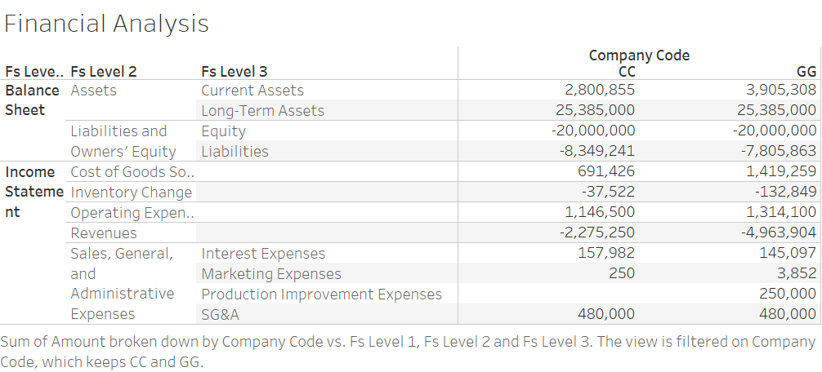

Firstly, let's begin with the Balance Sheet. Like taking a snapshot of a person's health with blood pressure, a balance sheet offers a snapshot of a company's financial health at a specific moment. It's crucial for understanding why Company CC is underperforming compared to Company GG. The balance sheet comprises three components: Assets, Liabilities, and Owners’ Equity. Through double entry, Assets should equal Liabilities plus Owners’ Equity, ensuring every euro is accounted for.

Upon reviewing Assets, both companies exhibit €25,385,000 of long-term assets, suggesting similar infrastructure. Thus, Company GG doesn't possess an inherent resource advantage over Company CC. However, the disparity lies in current assets, with Company GG boasting €3,905,308 compared to Company CC's €2,800,855, indicating a significant difference.

Examining Liabilities and Owners’ Equity reveals that both companies have identical Equity of €20,000,000, indicating equal funding from shareholders. Hence, the issue likely stems from liabilities, particularly debt. Company CC's net liability of €8,349,241 exceeds Company GG's €7,805,863, aligning with the discrepancy in Assets.

Moving to the Income Statement, which summarizes financial performance over a period, we gain insights into resource allocation. Company GG's higher Cost of Goods Sold (COGS) of €1,419,259 compared to Company CC's €691,426 suggests potential sales difficulties for Company CC.

Further analysis of Inventory Change corroborates this view, with Company GG's higher negative value indicating increased inventory purchases, possibly due to higher demand. Operating Expenses show Company GG spending 15% more than Company CC, but this is not a decisive factor.

Revenue reveals a significant contrast, with Company GG generating €4,963,904 compared to Company CC's €2,275,250. This discrepancy aligns with our COGS analysis, indicating sales challenges for Company CC.

A deep dive into Sales, General and Administrative Expenses exposes notable differences in Marketing Expenses and Production Improvement Expenses, highlighting potential areas for improvement.

In conclusion, Company CC faces sales challenges and lags in product marketing and production improvement. To address these issues, we'll analyze market demographics and marketing strategies in part one, followed by a closer examination of production methods in part two.

Part I – Demand Side Analysis

Let's begin by examining the demand side of our analysis. Demand stems from meeting consumers' tastes and needs, making it a crucial aspect of our market analysis. Given that every transaction is driven by satisfying a need or demand, understanding consumer preferences is paramount. Since each transaction ultimately translates into profits, we prioritize reviewing this section first.

**Marketing Expense Strategy**

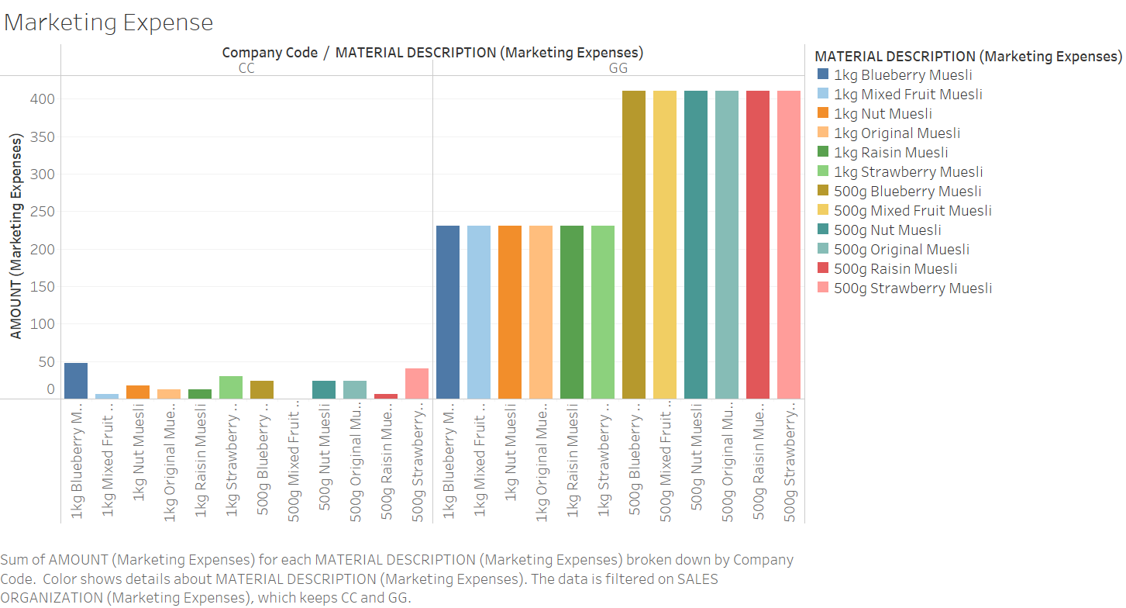

Let's start by examining the bar graph depicting each company's marketing expenses. On the y-axis, we have the amount of cash spent on marketing by each company, while the x-axis represents the range of products offered to consumers. The graph is divided into two sections: the left displays marketing expenses for Company CC, and the right shows expenses for Company GG. Different colors distinguish between various products, aiding in identifying any preferences.

Upon visual inspection, it's evident that Company GG overall allocates more funds to marketing, consistent with our earlier findings from the income statement. However, a closer examination is necessary to glean insights.

Analyzing Company CC's marketing expenses reveals that the top-promoted item is 1kg Blueberry, while the 500g mixed fruit receives no marketing expenditure. Whether this is an intentional decision, or a coincidence remains speculative. While it may suggest a preference for 1kg Blueberry among Company CC's customer base, the lack of correlation with Company GG's spending on similar items implies a lack of meaningful patterns. Apart from these observations, there are no discernible trends in Company CC's marketing efforts; all other items are promoted in a seemingly random manner.

Turning to Company GG's chart, no clear favorite among items emerges; all products receive equal marketing attention, as indicated by the uniform bar heights. However, a notable trend is the emphasis on 500g packages, suggesting a strategic focus on convenience. Company CC could consider adopting a similar approach to enhance sales. Despite this, the uniform spending across items of the same packaging size implies consistent consumer preferences across assorted products.

In summary:

* Company GG allocates more funds to marketing, with a preference for 500g packages.
* Company CC promotes 1kg Blueberry as its flagship item but neglects marketing 500g mixed fruits.
* Company CC may benefit from promoting 500g packaging to boost sales.

Upon comparing marketing expenditures, it's apparent that specific product promotion does not significantly impact Company GG's success over Company CC. However, further investigation into marketing channels and their effectiveness for both companies is warranted.

**Marketing to Sales Strategy**

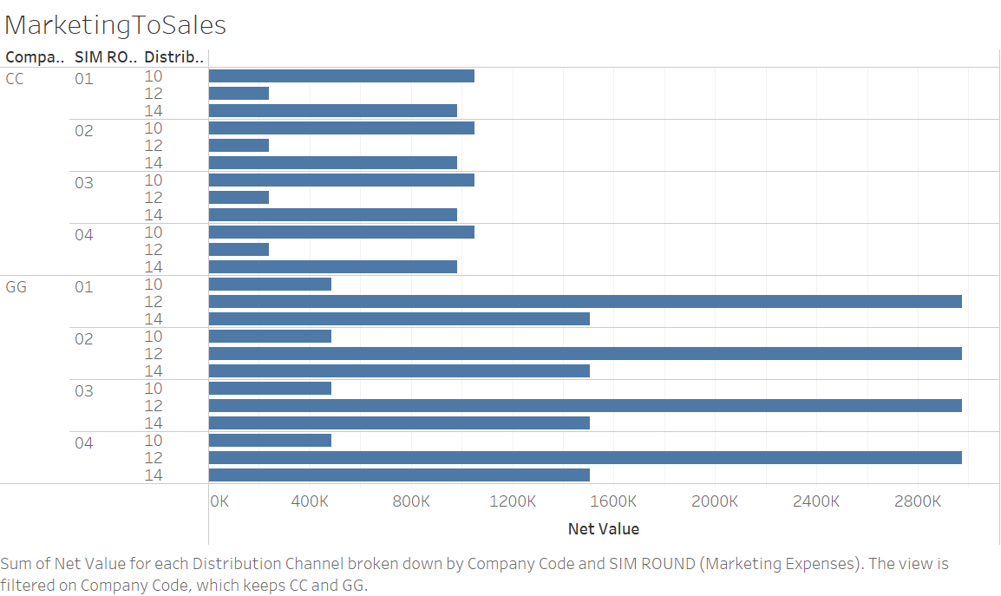

Our Marketing-to-Sales analysis provides valuable insights into our distribution channels. These channels, delineated numerically in our chart, encompass a variety of categories such as retailers, wholesalers, and online storefronts. The chart presents a horizontal bar graph sorted by company code and fiscal quarters (SIM Round), with each company's marketing expenses depicted as bar graphs relative to distribution channels 10, 12, and 14.

An initial comparison of marketing strategies between Company GG and Company CC reaffirms earlier findings regarding spending discrepancies. Notably, Company GG significantly outspends Company CC, aligning with previous observations from the Income Statement and Marketing Expense by Products.

Turning to the distribution allocation of Company CC, we observe a higher expenditure on Distribution Channels 10 and 14, with minimal funding allocated to Distribution Channel 12. Both Channels 10 and 14 consistently receive around €1000k each per fiscal quarter, whereas Distribution Channel 12 receives approximately €200k.

Conversely, Company GG's funding allocation follows a different pattern. The majority of funds are directed towards Distribution Channel 12, with over €280k allocated, followed by Distribution Channel 14, and the least expenditure on Distribution Channel 10. Unlike Company CC, Company GG's spending allocation exhibits a tiered structure, with a clear hierarchy of funding distribution. This deliberate strategy may indicate that Channel 12 offers optimal advantages over others.

While every channel warrants consideration, Company CC could benefit from reallocating funds from Channels 10 and 14 to Channel 12. This strategic adjustment holds potential for enhancing Company CC's marketing plan. Therefore, our recommendation suggests that Company CC should increase funding for Distribution Channel 12.

Moving forward, it's imperative to delve into the demographics of sales to gain a deeper understanding of where these distribution channels lead. By identifying our consumer demographics, we can better comprehend the flow of marketing distribution and tailor our strategies accordingly.

**Global Sales for Best and Worst Strategy**

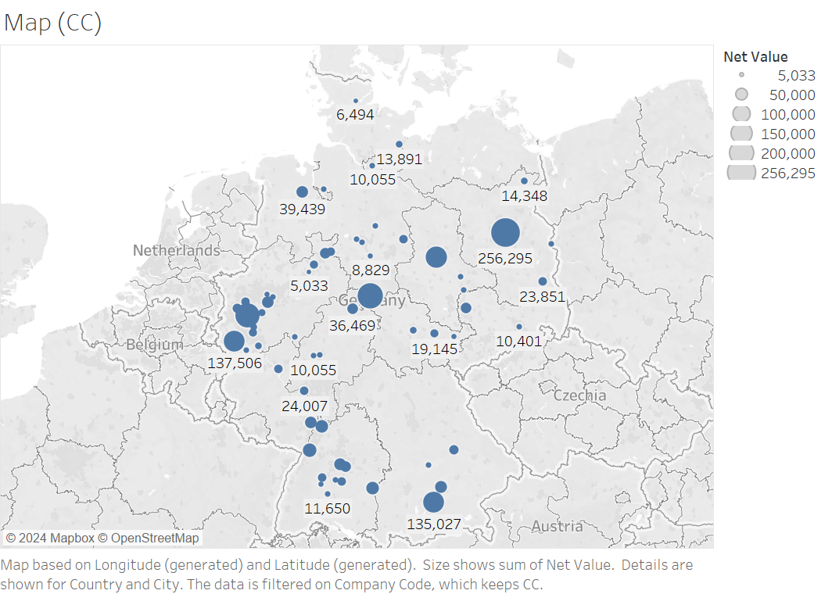

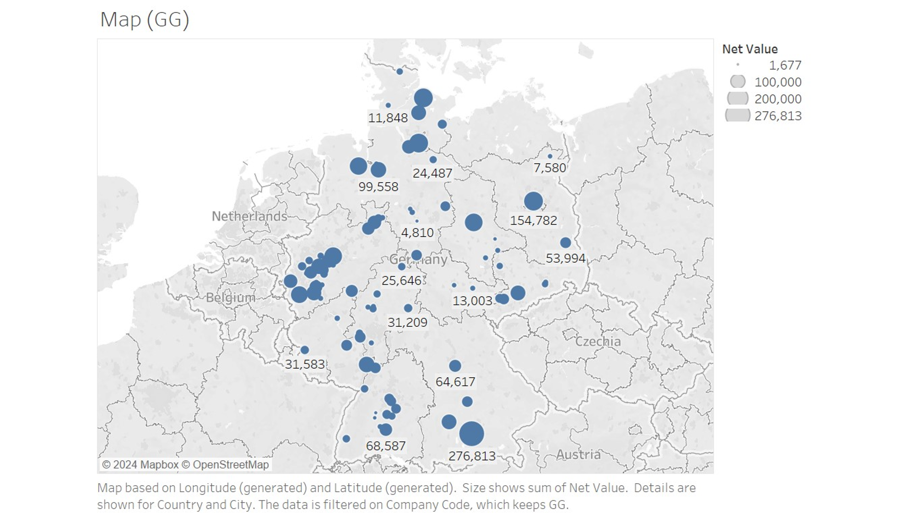

To gain deeper insights into our customer demographics, it's essential to explore their geographical distribution. Utilizing geographical dot maps based on sales data for each company can offer valuable insights into consumer locations. We'll utilize two maps: one for Company CC's customer base and another for Company GG's.

Both visuals depict Germany geographically, with dots representing sales locations. The size of each dot corresponds to the magnitude of sales, with larger circles indicating higher sales volumes.

Analyzing Company CC's sales map reveals a concentration of sales in specific cities. This is evident from the presence of a few large circles (representing sales exceeding €250,000) alongside numerous smaller dots (with values of €50,000 and below).

In contrast, Company GG's sales map displays a broader range of circle sizes, indicating a wider spread and range of sales with less concentration. The presence of intermediate-sized circles between the small dots and large circles suggests a more diverse distribution of sales. This broader range suggests that Company GG has a significantly broader reach, particularly in areas beyond Company CC's concentrated zones.

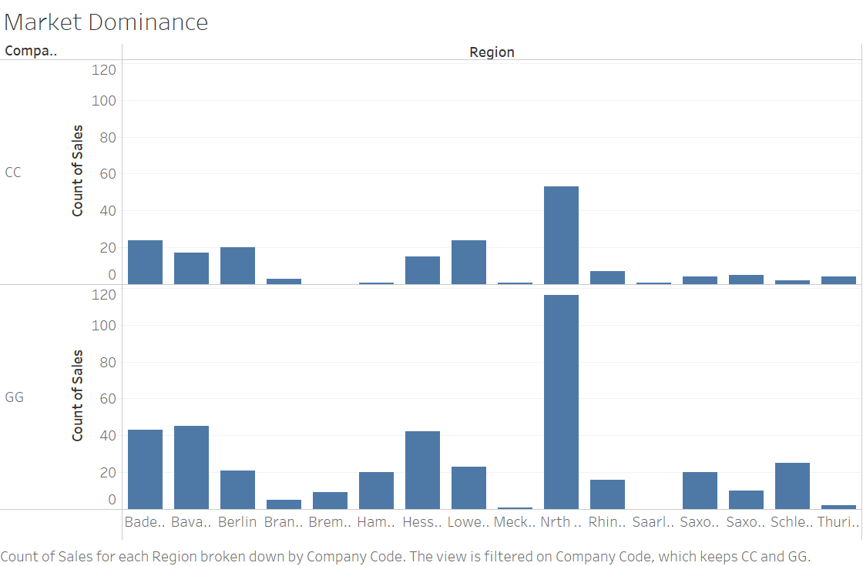

To gain a deeper understanding of our market demographics, let's examine the performance of each company across different regions. Our bar chart illustrates sales count on the y-axis and regions on the x-axis, with Company CC's data depicted at the top and Company GG's at the bottom.

Upon analyzing the charts, we notice that both companies experience the highest success in North Rhine Westfalia, indicated by the tallest bar for each. However, there are regions where activity is minimal for both companies: Bremen, Hamburg, Mecklenburg-Vorpomm, and Saarland for Company CC, and Mecklenburg-Vorpomm and Saarland for Company GG. These observations offer insights into our market demographics.

Comparing the two graphs, it's apparent that Mecklenburg-Vorpomm and Saarland may not have significant market demand for our products. While low sales in a region don't always indicate a complete absence of buyers or demand, the consistently low purchases across both companies suggest limited market potential. Consequently, it may not be in Company CC's best interest to pursue opportunities in these regions.

Taking a proactive approach, let's delve deeper into potential markets where Company CC could expand its presence. This strategic analysis will help identify promising opportunities for growth and development.

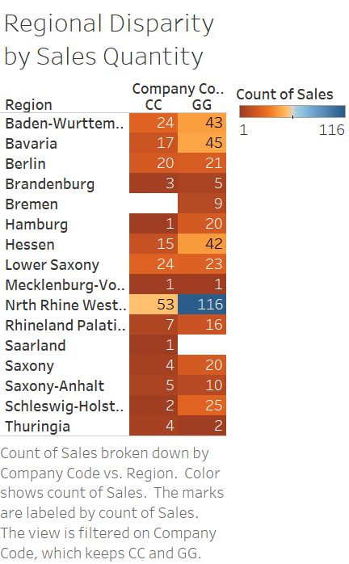

To enhance our understanding, let's utilize a heat map, which effectively highlights patterns and provides insights into our sales distribution across regions. In this analysis, we'll focus on sales count as the metric of interest, prioritizing insights into demographics and demand rather than price or product value.

Our heat map assigns regions their respective sales counts, employing a color spectrum ranging from dark brown to navy blue. Dark brown represents the least sales count, while navy blue indicates the highest. Transparency indicates proximity to the median or mean value, with darker colors indicating values closer to the extremes. If a value is extremely small or zero, the corresponding region is colored white. Our scale ranges from the minimum to maximum, excluding zero, with values ranging from 1 to 116.

In identifying potential markets for Company CC to focus on capturing more demand, we aim to identify regions where (1) both Company CC and Company GG perform similarly and (2) Company CC's performance is not at the lowest end of the spectrum, indicating a viable market worth pursuing.

Examining the heat map, we identify Berlin and Lower Saxony as promising markets for Company CC. In Berlin, Company CC is just one sale away from matching Company GG's sales count, indicating a competitive level playing field. Similarly, in Lower Saxony, Company CC leads by one sale, suggesting untapped potential. These markets appear ripe for expansion and offer Company CC a competitive arena to capitalize on.

Consequently, our analysis concludes that Company CC should shift its focus away from Mecklenburg-Vorpomm and Saarland and instead prioritize expanding its presence in Berlin and Lower Saxony.

**Pricing Strategy**

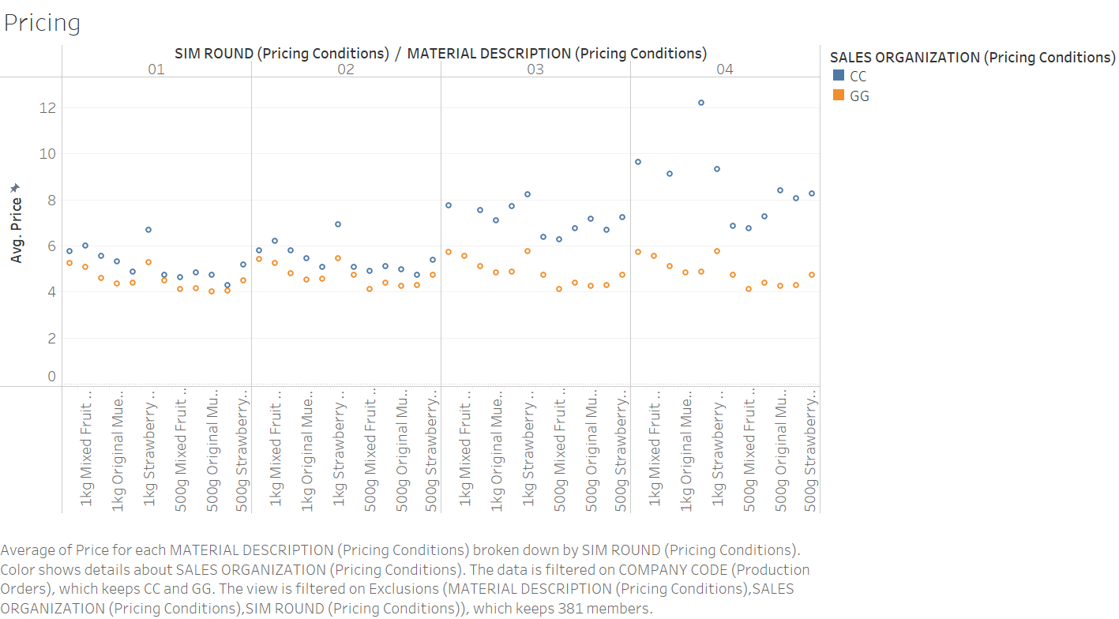

Next, let's delve into the pricing strategies employed by each company, a crucial aspect of business operations. Pricing directly impacts consumer behavior, with higher prices potentially deterring purchases. Therefore, it's imperative to assess whether the prices set by each company remain competitive.

In our chart, we represent Company CC's prices with blue dots and Company GG's prices with orange dots. The y-axis indicates the average prices for each item, while the x-axis lists the individual items sold to consumers.

With a glance at the chart, it becomes evident that Company CC is consistently pricing its products higher across the board. Notably, there are no blue dots (representing Company CC) below Company GG's price points. Ideally, we would expect to see a range of prices among products, with some priced above and some below Company GG's prices, including potential loss leaders aimed at attracting customers.

Several factors may contribute to Company CC's higher price index. It's possible that Company CC is targeting a more affluent demographic, with the higher prices reflecting premium positioning. Alternatively, geographic location could play a role, as urban centers typically entail higher price indexes. This observation aligns with our earlier findings indicating a concentrated consumer base for Company CC, further emphasizing the need to diversify its customer base.

Moving forward, we need to address potential production difficulties. As noted in our Income Statement analysis, Company CC has not allocated any funds to Production Improvement Expenses, unlike Company GG, which has allocated €250,000. This discrepancy warrants further investigation to identify and rectify any production-related challenges hindering Company CC's performance.

Part 2 – Supply Side Analysis

In this next segment, we're shifting our focus to analyzing the company from the supplier's standpoint, assessing any potential challenges in bringing the product to market. While demand is pivotal, it's equally crucial to ensure smooth supply operations, as consumers cannot make purchases if the product isn't available. Ultimately, without sales, there's no profit—a fundamental determinant of business success.

**Procurement Strategy**

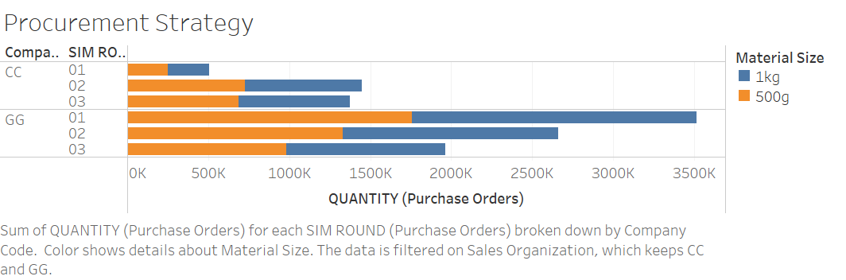

Let's start by examining the procurement strategies of both Company CC and Company GG. This entails evaluating the quantity of gross aggregate products ordered by each company. Our analysis is represented in a horizontal bar graph, with each fiscal year and company name on the vertical axis and quantity on the horizontal axis. The bars are color-coded, with orange indicating 500g packaging and blue representing 1kg packaging.

As anticipated, Company CC's gross purchase orders are notably lower compared to those of Company GG. In the initial fiscal quarter, Company CC made minimal purchases, maintaining a consistent quantity in the subsequent quarters. Interestingly, both 1kg and 500g packaging options seem to hold similar significance in the purchasing decisions of Company CC.

Conversely, Company GG exhibits significantly higher purchase volumes. This aligns with our findings from the Income Statement, where Company GG reported a considerably larger negative Inventory Change. Notably, Company GG initiates a substantial number of purchase orders in the first fiscal quarter, followed by a reduction in the second quarter, and a similar trend in the third quarter. While this could imply potential overstocking and projection errors, such details fall outside the scope of our current analysis.

It's noteworthy that both 1kg and 500g packaging options are purchased at comparable rates by Company GG. This contradicts their marketing strategy, which favors the promotion of 500g products over 1kg variants. Considering that marketing efforts may not always directly correlate with sales, it prompts a reassessment of the efficacy of promoting 500g products as a recommendation for Company CC.

However, it's essential to acknowledge that Company GG's promotion of 500g products may serve various purposes, such as appealing to specific demographics, maintaining a competitive edge, or bolstering brand reputation. For example, consumers might appreciate having a range of packaging sizes based on household size or individual preferences.

In summary, while marketing efforts warrant consideration, it's crucial to understand the multifaceted reasons behind procurement and promotional strategies before drawing definitive conclusions.

**Supply Strategy**

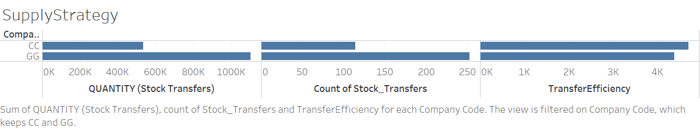

Taking a deeper dive into the supply side, let's examine our Supply Strategy chart, focusing on the metric known as Transfer Efficiency.

Transfer Efficiency comprises two key factors: Quantity of Stock Transfer and Count of Stock Transfer. In essence, it quantifies how much stock is moved per each movement. Higher transfer efficiency indicates that more stock is being moved with each transaction.

Assessing both manufacturing efficiency and transfer efficiency is crucial for identifying potential distribution issues. Any slowdown in either the manufacturing process or the transfer of products could disrupt the sales cycle. Whether it's a production halt or merchandise stuck in warehouses, such disruptions can lead to inefficiencies and hinder the ability to meet market demands optimally, resulting in reduced sales and profitability.

Upon reviewing our Supply Strategy chart, we observe the metrics associated with their respective magnitudes and companies. For instance, Company CC demonstrates a transfer efficiency of 5k, derived from 500k worth of stock quantity and 100 count of transfers. Company GG exhibits a slightly lower but comparable transfer efficiency value. Additionally, comparing Manufacturing Efficiency values, we find that Company GG is marginally more efficient than Company CC, consistent with our financial analysis indicating Company CC's lack of investment in production improvement.

While this provides insight into the effectiveness of our goods transfer process, further investigation is warranted. Let's delve deeper into assessing the performance of our production operations.

**Production Strategy**

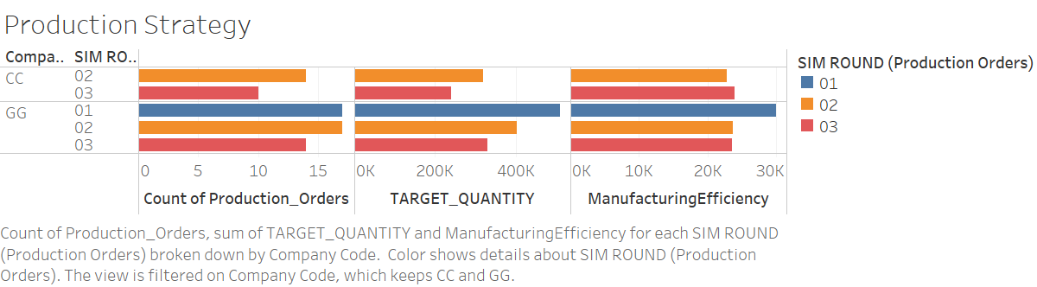

Our Production Strategy chart delves into manufacturing efficiency through two key metrics: Count of production orders and target quantity. Manufacturing Efficiency is calculated as the sum of the target quantity of purchase orders divided by the sum of production orders. Target quantity reflects the desired amount of sales within a specified period, while the count of purchase orders represents the actual generated orders. Essentially, manufacturing efficiency gauges how effectively a company meets its production goals. A higher manufacturing efficiency indicates that the company is producing more per purchase order.

Upon initial observation of the chart, it's evident that Company CC did not have any target quantities or production orders during the first fiscal round. This could suggest that there was no need for production during that period, potentially indicating a focus on clearing out existing inventory. This aligns with the income statement, which indicates a smaller inventory change for Company CC. However, Company CC initiates production in the second fiscal round with a competitive target, which is subsequently lowered by the third round, possibly indicating a decrease in demand.

Similarly, Company GG begins the year with a high target quantity, which gradually decreases over subsequent fiscal rounds. This trend mirrors Company CC's pattern of lowering target quantities each term, potentially reflecting a broader market trend rather than company-specific issues.

Regarding production orders, Company CC has no production orders as expected when there are no target quantities set for the same fiscal term. However, in the second fiscal term, Company CC generates a reasonable number of production orders, which decreases by the third fiscal term.

In contrast, Company GG initiates the year with a substantial number of production orders corresponding to its high target quantity for the first fiscal term. This trend continues into the second fiscal term but decreases by the third term, consistent with the declining target quantity trend.

Analyzing Manufacturing Efficiency, which integrates both production orders and target quantity, reveals similar values for both Company CC and Company GG across fiscal terms. Despite the underfunding in production by Company CC, the Manufacturing Efficiency values remain consistent for both companies, indicating that production efficiency is not a significant factor contributing to the profit disparity.

In conclusion, the data suggests that production, while differing in approach between the two companies, does not significantly impact the profit disparity observed between Company CC and Company GG.

Analysis Conclusion

While this statistical analysis isn't flawless, further exploration could provide additional insights to support decision-making. However, the findings of this report have identified sales and marketing as pivotal factors influencing profitability within this industry. This conclusion is supported by several key indicators, including Company CC's negative cash balance, insufficient marketing funds, underperformance in market demographic analysis, higher price index, and lower sales count. These indicators collectively suggest a challenging cash flow situation attributed to difficulties in attracting customers and generating sales.

Despite Company CC's underfunded production, its performance in supply logistics is relatively comparable to that of Company GG. This observation is highlighted by the similar values of manufacturing efficiency and transfer efficiency between the two companies. Consequently, supply logistics does not emerge as a significant contributor to profitability differentials.

In summary, while there may be areas for further investigation, the evidence strongly indicates that sales and marketing strategies play a central role in shaping profitability within the industry, whereas supply logistics, despite some disparities, does not appear to be a primary driver of profitability differentials between Company CC and Company GG.

Analyst recommendations

Based on our findings indicating that Company CC's primary challenge lies in marketing, it's imperative for the company to broaden its customer base and intensify marketing efforts to enhance revenue streams. Our analysis of Global Sales reveals that Company CC has been overly fixated on fiercely competitive markets, potentially resulting in elevated average price indexes and profitability hurdles. To strategize its market focus, Company CC should prioritize regions with promising success rates, while sidelining emerging markets lacking robust demand for its products. Specifically, expansion efforts into areas like Berlin or Lower Saxony, where market dominance hasn't been firmly established, could yield favorable outcomes.

Moreover, Company CC stands to benefit from a refined marketing approach tailored to its product offerings. This entails allocating resources towards promoting products catering to specific demographic preferences, such as blueberry-flavored items, and tailoring packaging sizes to suit varied consumer lifestyles, like offering 1kg options for bulk buyers and 500g packs for busy professionals. This strategic alignment with consumer needs may pave the way for effective branding initiatives. While our analysis hasn't yielded definitive demographic insights, further research into consumer demand and profiles could provide valuable guidance.

Additionally, leveraging its higher price index, Company CC could target more affluent consumers akin to those patronizing upscale retailers like Whole Foods or Erewhon. However, it's crucial to balance this approach with broader market accessibility, as targeting niche demographics may pose challenges in achieving widespread market acceptance. Within its marketing endeavors, allocating increased resources to Marketing Channel 12, which exhibits potential for broader reach and success, could be advantageous.

Furthermore, while our analysis underscores the need for Company CC to invest in production enhancements for long-term competitiveness, it's worth noting that the company currently meets its supply requirements comparably to Company GG. Thus, while continued investment in production improvements remains advisable for future strategic gains, addressing immediate marketing challenges takes precedence for short-term objectives.